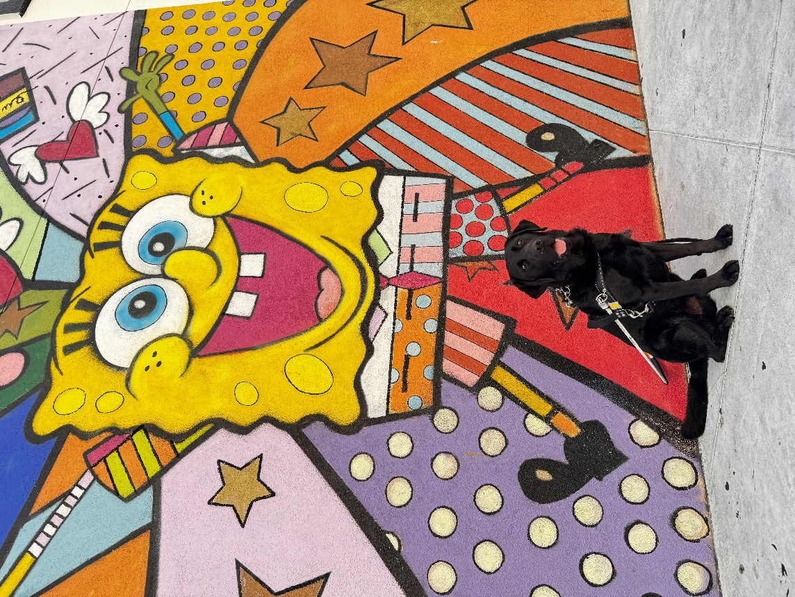

Hi family,

I hope you’re all doing well! I’m having such a great time here and staying cool. The trainers are gearing up for class to start, and it’s so exciting! When we’re not out training, the kennel techs and volunteers have been throwing fun pool parties and giving us frozen treats- it’s been so much fun! Well, I should get back to studying now, but I wanted to send my love. I’m doing well and thinking of you!

Wags & Kisses

[](http://www.bing.com/images/search?q=Dog+Paw+Print&Form=IRTRRL#view=detail&id=9B5FA9944B7CDA95F228F85088B4D3BB578B69FE&selectedIndex=73)

Whelan